***POLO WATCH222***

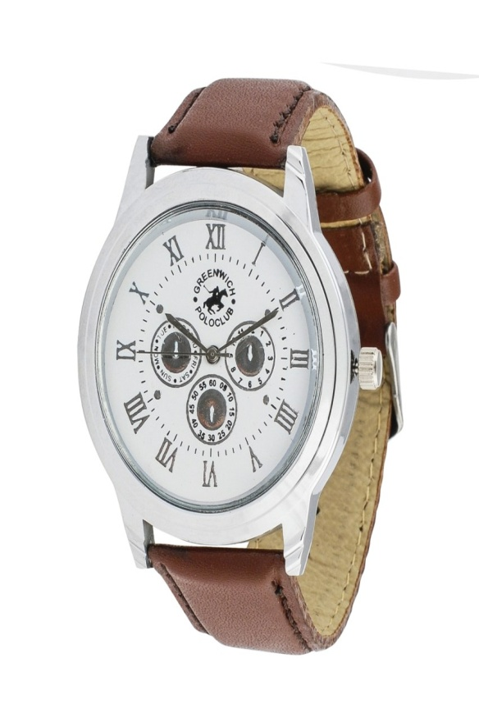

***DESCRIPTION:***

**POLO’S WATCH MOST VALUABLE AND BEST SELLING PRODUCT ALL OVER THE WORLD.THEY ARE LOTS OF VARIOUS COLOR AVAILABLE IN MARKETS.LEVIS WATCH WE CAN ALSO SEE OTHER COUNTRIES OF TIME BECAUSE ITS HAVE THE ADVANCE TECHNOLOGY OF LEVIS WATCH.**